
A) From the beginning, Good News Club has been at the
heart of our worldwide ministry. Trained volunteers meet once a week
with groups of children for between 60-90 minutes one afternoon or
evening per week —usually during the school year—in schools, homes,
churches, community centers, apartment complexes and anywhere
children can easily and safely gather. Children attend Good News Club®
(GNC™) only with parental permission.
The exciting fun-filled club time includes Scripture memory, songs, prayer
time, a mission story, Wonder Time™, a review game, and a dynamic Bible
lesson using colorful materials from CEF Press. Each club includes a clear
presentation of the Gospel. Clubs include strong discipleship training:
children learn that God loves them, that every person has value, and that
God can help them do the right thing. They learn how to find victory in
hard times and how to show love to others.
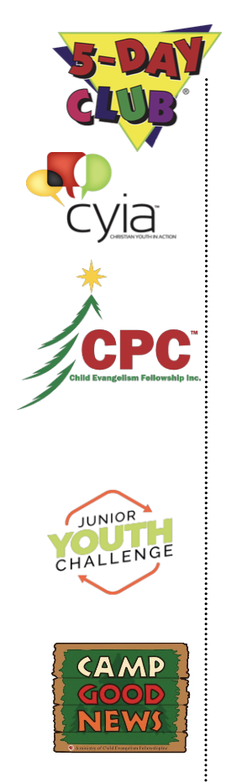

B) 5-Day Clubs take place over the course of a five-day period
during the summer months and offers a unique opportunity for
children to interact with youth who receive training in our youth program.

Christian Youth in Action® (CYIA™) is a program designed to train
young people starting at age 14 in effective and engaging ways to teach
children about God.

C) Christmas Party Club ministry challenges Christians to hold
Christmas Party Clubs to let children know the true meaning of
Christmas. These provide a unique opportunity to reach many children
during this festive time of the year.

D) Party Clubs are one-time evangelistic clubs held
throughout the year at special times such as Easter, Valentines or
Thanksgiving. Party Clubs are often held in new and previously
unreached areas.

E) Junior Youth Challenge is an avenue for ongoing
discipleship. CEF is serious about discipleship. The Good News Club
ministry is a primary means of discipling children, but when pre-teens
age out of GNC, we want them to continue growing in their walk with
Christ, being involved in local churches and JYC™ provides that link.

F) Open Air ministry provides an opportunity to reach children with
the Gospel during a fair, festival, expo or carnival.

G) Camp Good News ranges from day-camp to overnight camp. It has
long been one of the children's favorite CEF ministries. Camp Good
News® is available in various locations throughout the USA.


H) Military Children’s Ministry works on military bases to reach children
in military families. Military life can be difficult for all involved.
Children in military families need people in their lives to anchor them
in Jesus Christ, the Rock of Ages. A Good News Club held at a home or
school in a military neighborhood provides stability and life-changing
truth.

I) Digital Ministry including U-Nite TV®, U-Nite Kids®, and U-
Nite Radio® unite children with the Gospel where they are—online.
Children enjoy animated adventures, music videos to learn and
memorize God’s Word, stories and much more. Learn more about
how CEF’s newest ministry is reaching thousands of children over the
internet at cefonline.com/unite.

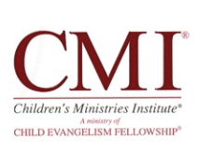

J) Children’s Ministry Institute provides specialized, practical training
in children’s ministries not found in Bible Colleges or Christian
Universities. CMI® equips Christians to understand, evangelize and
disciple children and to administrate and lead a children’s ministry.
Visit cefcmi.com for modular courses offered on campus and online.

